# CS 255 System Design Document Template

By: Alex Roberts

## UML Diagrams

### UML Use Case Diagram

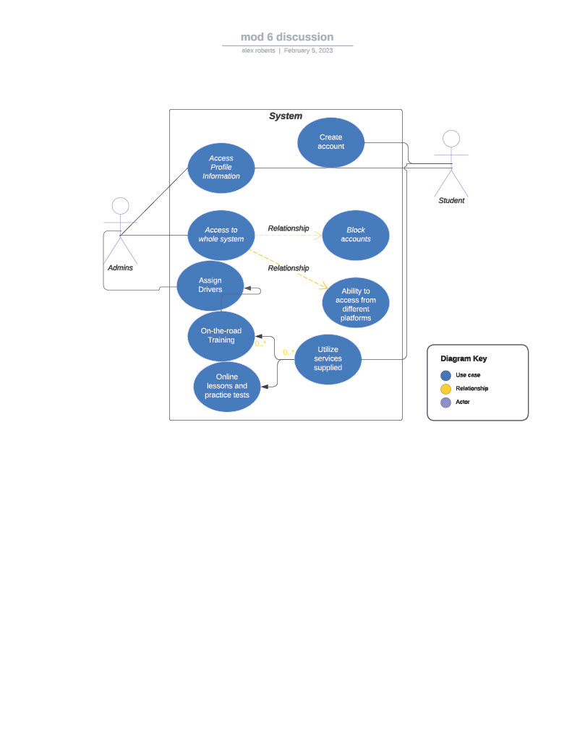

### UML Activity Diagrams

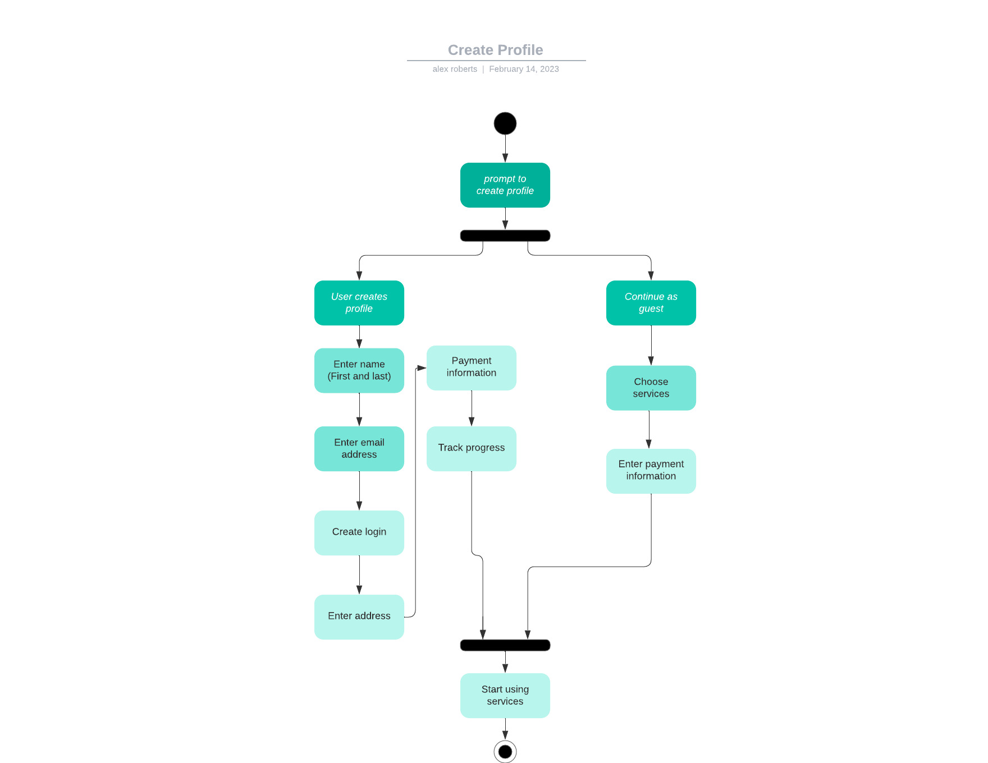

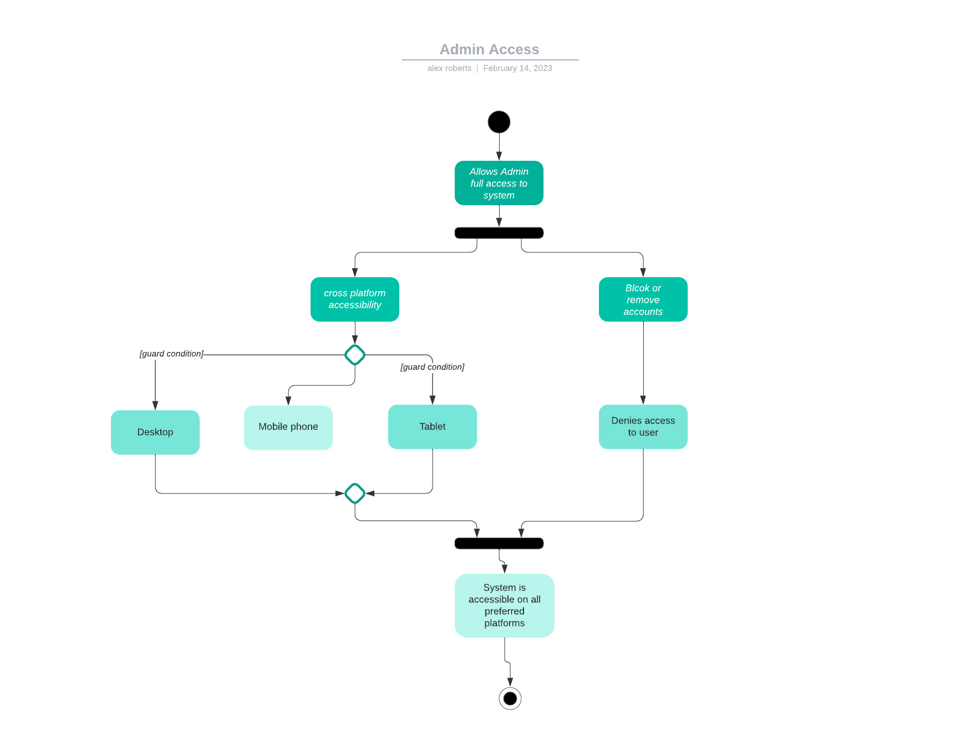

### UML Sequence Diagram

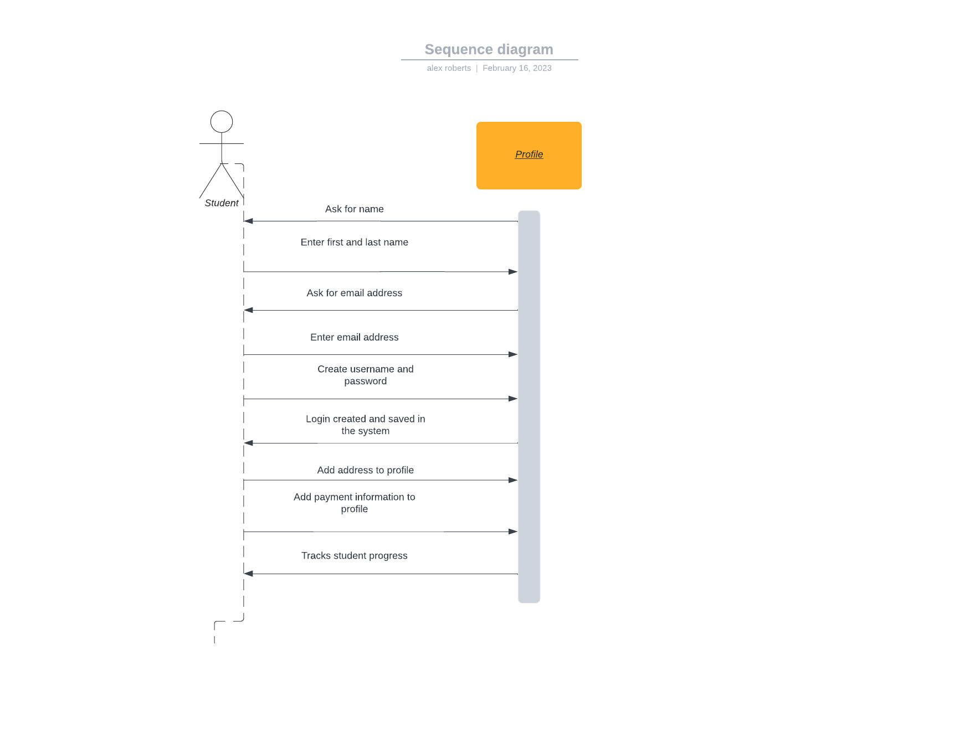

### UML Class Diagram

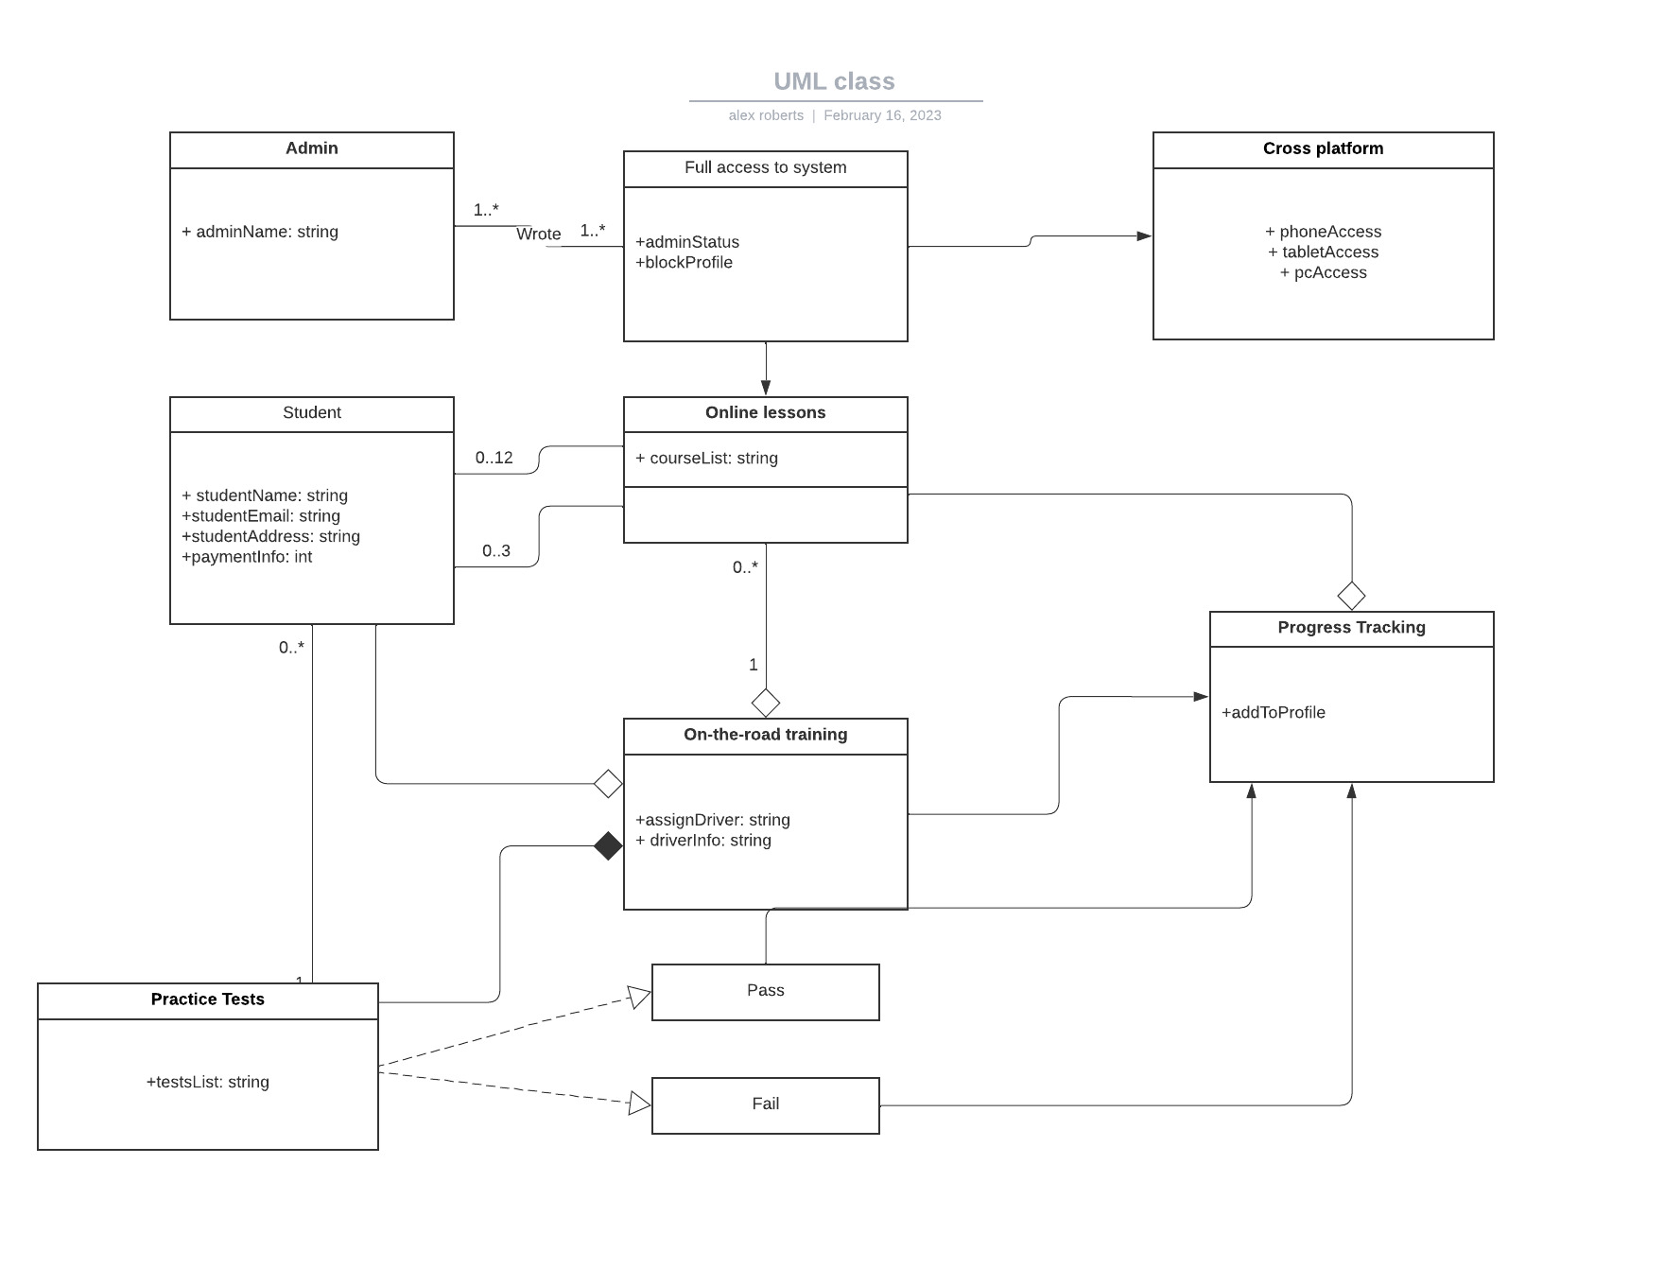

## Technical Requirements

* It needs to be able to run on PC and mobile devices (tablet and phone)
* The system should run as fast as we possibly can make it so they can have their results as efficiently as possible and updates can be applied as quickly as we can put them out.
* It should be updated regularly as often as the client wants new content or if things need to be fixed.
* This program should be able to run on any web-based OS since people prefer different ones and the client would want to be able to help as many people as possible.
* It would require a database since there will be user information so it can all be stored somewhere safely and in one place.
* They can put all of their personal information in the system including first and last name, email, and address so we can distinguish between them.
* Passwords should be case-sensitive
* The system should inform the admin if there are multiple failed attempts for a user logging in so they can keep an eye on it and lock them out if needed to prevent hacking or identity theft.
* Also, if there are any crashes or other problems with the program.
* We should implement changing user info and status without using the code to give access to the admins in case of hiring, blocking, giving certain people access to different information, and to allow the students to update their info.
* The system will need to adapt to updates and we can ensure this by making our code flexible and keeping in mind what we may need to fix later. Planning updates ahead of time would be beneficial.
* The admin needs full access to the system and information.
* Email and password will be required to login
* We can consider two-factor authentication and security questions for optimal security
* If there is too many login attempts (five) or if the two-factor authentication fails the account will be locked and they will have to contact the admins (which will be provided) and they will have to provide information and answers to security questions to unlock it.
* If the user forgets their password they can contact an admin or go through a “forgot password” process that will ask security questions
* The system shall validate user credentials when logging in
* The system shall lock out users for failed login attempts
* The system shall allow the user to get back into their account through a series of security questions
* The system shall allow admins to access all information going in and out
* The system shall supply the users with classes and practice tests
* The system shall show user status regarding classes and tests that the user and admin can view
* The system shall allow the users to schedule on-the-road driving practice
* The system shall allow multiple OS and platforms